Project Identification Form (PIF).
Project Type: Full Sized Project
Type of Trust Fund:GEF Trust Fund

For more information about GEF, visit TheGEF.org
PART I: Project Information
Project Title: | De-risking Renewable Energy Investment in Kazakhstan
Country(ies): | Kazakhstan | GEF Project ID: |  | 9192
GEF Agency(ies): | UNDP | GEF Agency Project ID: |  | 5490
Other Executing Partner(s): | Ministry of Energy of Kazakhstan | Submission Date:  Resubmission Date |  | 16 July 2015  31 July 2015
GEF Focal Area(s): | Climate Change | Project Duration (Months) |  | 60 months
Integrated Approach Pilot | IAP-Cities IAP-Commodities IAP-Food Security |  | Corporate Program: SGP
Name of parent program: | NA | GEF Agency Fee ($) |  | 428,450
A. indicative Focal Area Strategy Framework and Other Program Strategies:
Objectives/Programs (Focal Areas, Integrated Approach Pilot, Corporate Programs) | Trust Fund | (in $)
 | Trust Fund | GEF Project Financing | Co-financing
CCM-1 Program 1: Promote timely development, demonstration and financing of low-carbon technologies and mitigation options | GEF TF | 4,510,000 | 32,450,000
Total Project Cost |  | 4,510,000 | 32,450,000
- indicative Project description summary

Project Objective: To promote private-sector investment in large and small-scale renewable energy in order to achieve Kazakhstan’s 2030 renewable energy target
Project Component | Financing Type | Project Outcomes | Project outputs | Trust Fund | (in $)
 |  |  |  |  | GEF Project Financing | Co-financing
1: Large Scale Renewable Energy: Policy and Financial De-risking Measures | TA | Appropriate policies, programmes and regulations are in place to reduce investors’ risks, scale-up investment and enable the achievement of 2030 RES target | - Improving FIT design and contractual arragement for RES producers  - Guarantee mechanism for PPA in place (co-financed)  - Updated grid code  - Training provided to 20 KEGOC staff to improve grid management and planning  - RES balancing costs (to meet 2030/2050 targets) assessed and integrated in KEGOC investment plan  - National resource mapping and market study for solar PV and bioenergy conducted  - Economic analyses into the most cost-effective design of instruments (policy de-risking, financial derisking and financial incentives) to achieve 2030 target conducted | GEF TF | 700,000 | 1,200,000
2: Renewable Energy for Life: Policy De-risking Measures | TA | Appropriate policies, programmes and capacities are in place to reduce risk and attract investment in small-scale (on-grid and off-grid) RES for homeowners and (agro)businesses | - National targets for small-scale RES;  - Monitoring system and data-base for small scale RES  - Regulations for small RES: net-metering policy (on grid); simplified PPAs, grid-connection procedures  - Simplified permits and licensing process for small RES  - Campaigns to inform end-users/potential developers of the benefits of small-scale RE;  - Standards, testing and certification in place for solar PV  - At least 10,000 people received training for renewable energy (installation, operations and maintenance) – at least 50% women | GEF TF | 1,100,000 | 1,100,000
3: Renewable Energy for Life: Financial De-risking & Direct Financial Incentives | TA | Sustainable business models and financial mechanisms to support their implementation in place for investment in small-scale urban and rural RES solutions | - 5 new business models for small-scale urban and rural RES application designed and tested:  - 3 models for urban RES applications involving Association of Apartment Owners, RESCO and/or Municiplaities; and  - 2 models for rural RES applications for farm/community-level and for household level  - 5 model contracts and institutional arrangements for business models designed and approved by Government | GEF TF | 600,000 | 1,300,000
 | Inv |  | RES for Urban Life:  - At least 140 buildings-level RES applications built and operate on sustainable basis  - At least 18,000 people benefit from improved energy access (at least 50% - women)  RES for Rural Life:  - At least 240 farming communities with RES-based system for energy supply  - At least 10,000 people benefit from improved energy access (at least 50% - women)  Scaling-up RES for Life:  - Financing products and public incentive schemes from banking sector and the Government to promote mass market for RES products and services |  | 1,900,000 | 28,000,000
Subtotal |  |  |  |  | 4,300,000 | 31,600,000
Project Management Cost (PMC) |  |  |  | GEF TF | 210,000 | 850,000
Total Project Cost |  |  |  |  | 4,510,000 | 32,450,000

- Indicative sources of Co-financing for the project by name and by type, if available
Please include confirmed co-financing letters for the project with this form.
Sources of Co-financing | Name of Co-financier | Type of Co-financing | Amount ($)
Recipient Government | Ministry of Energy | In-kind | 250,000
GEF Agency | UNDP | Grants | 100,000
Recipient Government | Renewable Energy Transfers Programmes | Grants | 3,000,000
Recipient Government | State Programme on Water Supply to Farming Communities | Grants | 15,000,000
Private Sector | Ergonomika Ltd. | Equity | 2,000,000
Private Sector | JSC International Center for Energy Efficiency “ProEco” | Equity | 800,000
Private sector | JSC Astana Solar | Equity | 3,000,000
Private Sector | “Rodina” Farming Community | Equity | 500,000
IFI | IFC | Grant | 1,200,000
IFI | EBRD/CIF | Soft loan | 5,500,000
Civil Society | Kazakhstan Green Building Council | In-kind | 300,000
Others | Nazarbaev University | In-kind | 300,000
Others | Public Research Institute “KazEcoTerm” | In-kind | 500,000
Total Co-financing |  |  | 32,450,000
- Indicative Trust Fund Resources Requested by Agency(ies), Country(ies) and the Programming of Funds
GEF Agency | Trust Fund | Country/  Regional/ Global | Focal Area | Programming  of Funds | (in $)
 |  |  |  |  | GEF Project Financing (a) | Agency Fee (b)^{b)} | Total  (c)=a+b
 |  | Kazakhstan |  |  | 4,510,000 | 428,450 | 4,938,450
Total GEF Resources |  |  |  |  | 4,510,000 | 428,450 | 4,938,450

E. Project preparation grant (ppg)
Is Project Preparation Grant requested? Yes No If no, skip item E.

PPG Amount requested by agency(ies), Trust Fund, country(ies) and the Programming of funds
Project Preparation Grant amount requested: $150,000 PPG Agency Fee: 14,250
GEF Agency | Trust Fund | Country/  Regional/Global | Focal Area | Programming  of Funds | (in $)
 |  |  |  |  | PPG (a) | Agency  Fee (b) | Total  c = a + b
 |  | Kazakhstan |  |  | 150,000 | 14,250 | 164,250
Total PPG Amount |  |  |  |  | 150,000 | 14,250 | 164,250

- Project’s Target Contributions to Global Environmental Benefits
Provide the expected project targets as appropriate.
Corporate Results | Replenishment Targets | Project Targets
- 4. Support to transformational shifts towards a low-emission and resilient development path | 750 million tons of CO_{2e} mitigated (include both direct and indirect) | 5.3 million tons of CO_{2e}

part ii: project JustiFication
Project Overview
1. Project Description.
1.1. Global environmental problems, root causes and barriers that need to be addressed
- Kazakhstan is by far the largest GHG emitter in Central Asia with annual emissions of 284 Mt CO2e in 2012. In relative terms, it has one of the world’s highest GHG emissions per capita (16.9 tCO2) and the energy intensity of its economy – 0.68 toe per 1000 US dollar of GDP – is almost six times that of Western Europe (0.11) and almost triple that of the US (0.24). GHG emissions have been steadily rising since the early 2000s, when the emissions bottomed out at around 146 Mt CO2e, or 41% of the 1990 peak level of 358 Mt CO2e (Figure 1). In the energy sector, which is the largest GHG emitting sector accounting for 85% of all emissions, the rise in GHG emissions was mostly caused by steady economic growth/increased energy demand and a high reliance on GHG intense fuels (predominantly coal), as well as on outdated and inefficient energy generation and transmission infrastructure. Coal makes up some 75-80 percent of fuel in electricity power generation whereas renewable energy accounts only for roughly 10 percent. Yet even this 10% comes almost solely from large hydro power plants. Without large hydropower, renewable energy makes only 0.06 percent of Kazakhstan’s total primary energy supply.
Figure 1: GHG emissions by sector, in millions tons of CO2-eq (excluding LULUCF)
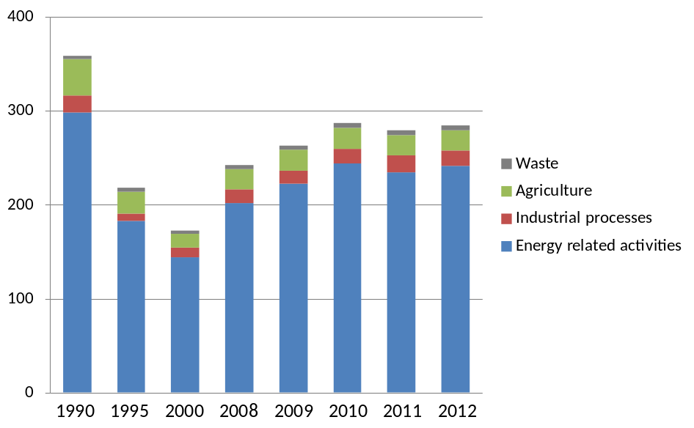
Source: Graph based on data from Kazakhstan National Inventory Report to UNFCCC, 2014

- Kazakhstan is a net electricity exporter, however, there are major regional imbalances in electricity supply and demand between Southern and Northern regions of the country. The situation is particularly problematic in the South, where the lack of power generation facilities and insufficient capacity of transmission lines, force Kazakhstan to import electricity from the neighboring countries in order to meet electricity demand. Also, the large size of the country and low population density requires highly costly extension and maintenance of transmission lines to connect remote areas to the electricity grid. In some areas, transmission losses reach up 15 -25 %.
- On the other hand, Kazakhstan has enormous renewable energy potential, particularly from solar and wind (Figure 2). It is estimated that the country has the potential to generate 10 times as much power as it currently needs from wind energy alone. Increased renewable energy deployment could increase the reliability of electricity supply and decrease GHG emissions and carbon intensity. A more reliable and efficient energy supply will bear benefits for Kazakhstan’s energy customers, economy and the environment.
Figure 2 – Installed Electricity Capacity and Technical Potential of Renewable Sources in Kazakhstan
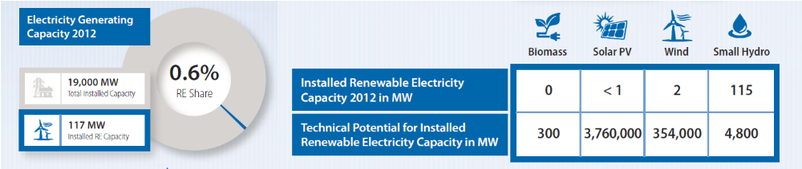
Source: UNDP 2014, Renewable Energy Country Snapshot Kazakhstan

- However, a variety of investment risks associated with early-stage renewable energy markets are preventing renewable energy market growth in Kazakhstan. The DREI methodology, developed by UNDP, has been applied in the design of this project in order to perform a preliminary analysis to identify and understand the main categories of risks and underlying barriers for investment in both large/utility-scale RES projects and decentralized small-scale (off-grid and on-grid) RES applications. The theory of change underlying the DREI methodology is that one of the principal challenges for scaling-up RES in developing countries is to lower the financing costs that affect renewables’ competitiveness against baseline technologies – i.e. primarily fossil fuels. As these higher financing costs reflect barriers and associated risks in the investment environment, the key entry point for policy-makers to promote RES is to address these risks and thereby lower the overall life-cycle generation costs of RES.
- The risk categories and underlying barriers that form the starting framework for analysis in Kazakhstan are described in Tables 1 and 2 for large-scale and small-scale RES projects respectively. For large-scale RES projects, the risk categories that the preliminary analysis has identified as most relevant are: power market risk, grid management risk, resource & technology risk, currency/macro-economic risk, and counterparty risk. For small-scale RES, additional high-risk categories are permits risks, social acceptance risk, development and O&M risk, and financial sector risk. The higher risks and the correspondingly higher costs of capital would require higher returns to justify investments, making investments in RES less attractive.
Table 1: Large-scale RES projects - Risks and barriers in Kazakhstan
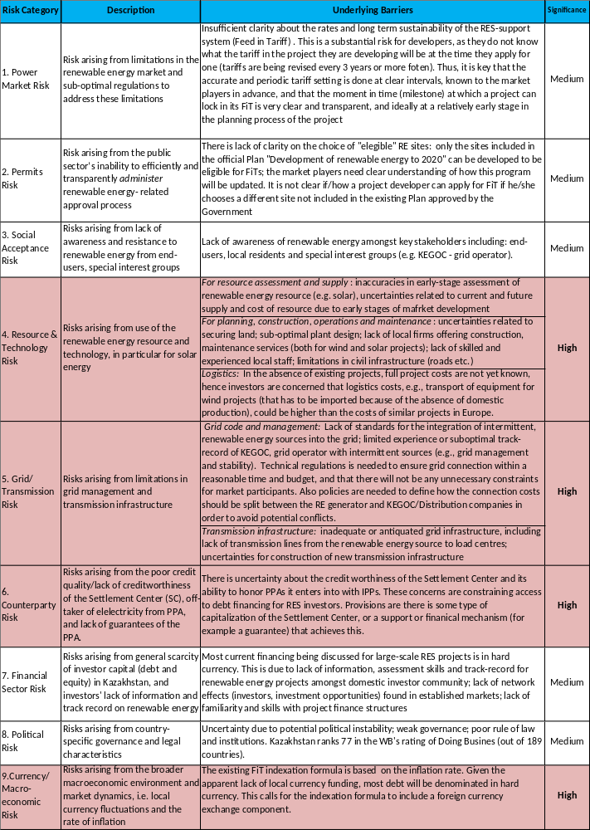
Table 2: Small-scale RES project - Risk and barriers in Kazakhstan

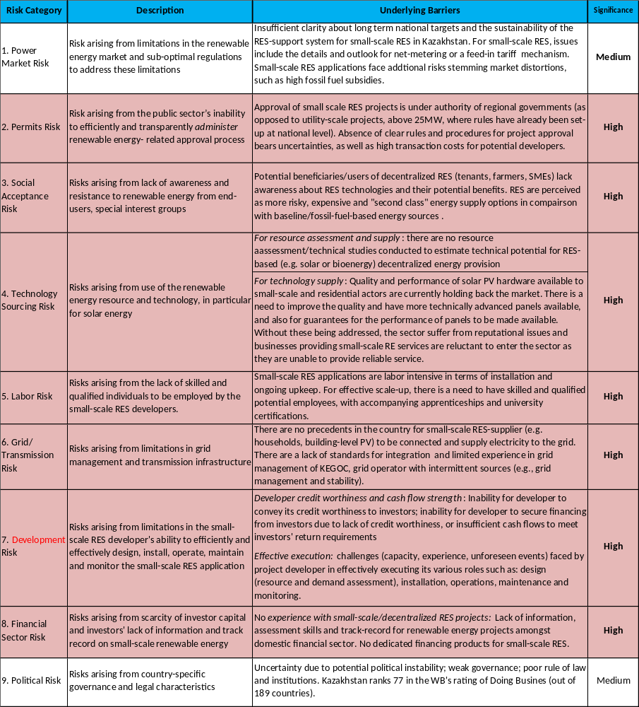
1.2 Baseline scenario or any other associated baseline projects
- The Concept of Transition to Green Economy of Kazakhstan serves as the main document for state planning nd target setting in the area of renewable energy (Government decree N79, May 30, 2013). The concept established the following ambitious targets:
    - 3% share of renewable energy in generation by 2020;
    - 30% share of renewable energy in generation by 2030;
    - 50% share of renewable energy in generation by 2050.

- To facilitate the achievement of RES targets the Law on Renewable Energy Sources has been adopted in 2009 and further amended in 2013 putting in place following important provisions:
    - Establishment of feed-in-tariffs for different categoris of renewables fixed for 15 years (Table 3)
    - Establishing priority dispatch and grid access for RES projects;
    - Establishing obligatory purchase of RE power by the Settlement Center;
    - Adoption of prototype Power Purchase Agreement (PPA);
    - Introduction of targeted support (subsidy scheme) for RE developers, not having access to the grid in remote areas of Kazakhstan (Renewable Energy Transfers Programme)

Table 3: Eligible RES technologies and fixed rate of feed-in-tariffs in Kazakh Tenge (KZT) and USD
Eligible Technologies | Fixed Feed-in-tariff  KZT/MWh | Feed-in-tariff  US$/MWh  (July 2015)
Wind | 22,680 | 121.94
Solar PV | 34,610 | 186.08
Small hydropower | 16,710 | 89.84
Biogas | 32,230 | 173.28
Source: Resolution of the Government of Kazakhstan #645 “On approval of fixed tariffs for RES” dated 12 July 2014

- Adoption of long-term RES targets and the new regulatory framework by the Government has been welcomed as an important step toward developing the Kazakh renewable energy sector and boosted investors’ interest in RES projects. Since the adoption of the framework in 2009-2013, over 300 MW of RES-based capacity has been approved and/or put in operation (Table 4) and additional projects for over 450 MW have been submitted for approval by the Government. If all planned investments materialize, the 2020 3% RES target will be met.

Table 4: Existing and approved RES projects in Kazakstan
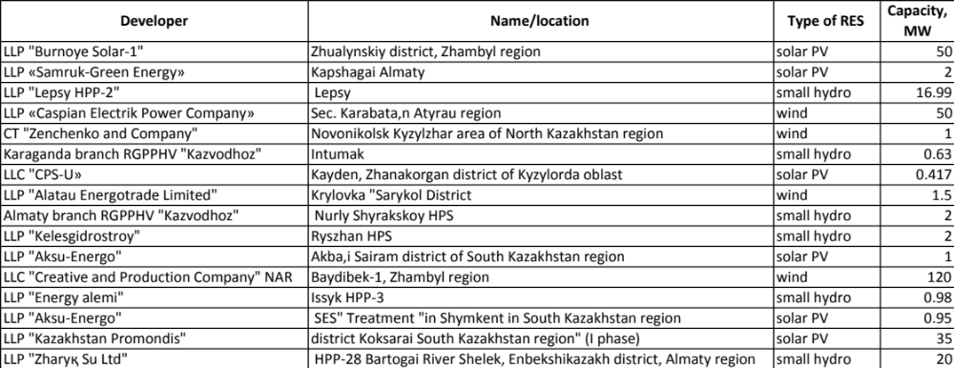
Source: Ministry of Energy of Kazakhstan

- However, based on interviews with existing and potential private investors, the achievement of 2020 target is far from guaranteed while the prospects of reaching much more ambitious 30% 2030 target is even less likely under the current framework. As expected, for a new and emerging sector and regulatory environment, a number of open issues remain and require continued attention and refinement. In particular, three key sources of risks, which have to be addressed as a first priority, are (for detailed account of risks – see Table 1):

    - Counterparty risk: According to the RES Law, the buyer under PPA is the Settlement Center (SC) established by the KEGOC, grid operator, as an independent limited liability company (LLC). The level of SC’s capitalization, as well as the degree to which Kazakhstan stands behind SC, is uncertain and there is a concern amongst possible lenders to RES projects of situations where the SC may not be able to honor its contractual obligations.. The current structure is therefore constraining access to debt financing for RES investors.

    - Currency risk: RES tariffs are fixed in local currency (Kazakh Tenge) for 15 years and the existing FiT indexation formula is based on the inflation rate. However, given the lack of local currency funding, most debt is expected to be denominated in hard currency. This calls for the indexation formula to include a foreign currency exchange component.

    - Grid management risk: The Grid Code, developed back in the 1970s, is no longer adequate to address the needs of present day system, in particular the challenge of managing up-take of decentralized and intermittend RES-based energy. From technical perspective, integration of renewable energy sources, such as wind and solar, will require resources and capacities to balance and control supply and demand and ensure the adequacy of the network to absorb intermittent renewable power into the grid.

- In addition, a number of other risks, such as resource/technology risk, power market risk, social acceptance, financial sector risks, etc (see Table 1) also need to be addressed to unlock additional and larger flows of private investment for large-scale RES projects in Kazakhstan. Detailed quantitative analysis fo risks and their impact on the project cost and LCOE will be conducted at PPG stage to identify the most important ones from investor’s perspective that the proposed project will then seek to address.

- As the Table 4 illustrates, for the most part RES installations in Kazakhstan fall under category of large utility-scale projects (over 1 MW). This situation reflects the fact that small, micro and mini (household-level) RES projects and applications face additional risks that impede investors, even despite availability of a dedicated subsidy scheme introduced by the Government as part of RES support package (i.e provision of 50% grant). The scheme has been rarely used, indicating that even such high level of subsidies is not sufficient to ensure attractive risk/return profile for such projects. This also reflects general perception among public and businesses towards RES in Kazakhstan that these technologies are not for ordinary people and businesses (i.e. not for daily life), but rather something expensive, exotic, risky and not very reliable, etc. To confront such perception, the project will introduce two categories of “RES for life” applications (see Component 3), which cover various small and micro-scale RE projects, both on-grid and off-grid, such as building/household-level PV, solar water heating, on-farm biogas, etc. Research and interviews at PIF design stage reveal that “RES for life” projects face various additional categories of risks; here is the summary of major ones, whereas full list of risks is presented in the Table 2.

    - Permit risks: the approval process for small project is even more cumbersome, uncertain and therefore costlier and riskier than for large scale projects as it falls under the responsibility of reginal authorities (akimats). Institutional and human capacities of regional authorities to handle the approval process in efficient, open and transparent manner are extremely limited (this risk is relevant to both off-grid and on-grid projects);
    - Social-acceptance risks: There is a widespread perception among Kazakhstani population (i.e. potential developers and end-users) that RES are expensive, unreliable and “second class” energy supply sources. Awareness about existing RES support policies among population is virtually non-existent (this risk is applicable to both off-grid and on-grid RES projects);
    - Technology sourcing risks: Quality and performance of solar PV hardware available to small-scale and residential actors are currently holding back the market (and negatively contribute to the social-acceptance risk). Solar PV hardware available on the market is of inferior quality and lacks performance guarantees (this risk is applicable to both off-grid and on-grid RES projects);
    - Development risk: potential developers for “RES for life” projects (i.e. small businesses, farmers, tenants) do not have strong credit history/creditworthiness and sufficient cash flow; also there is limited capacity in Kazakhstan for RES project planning, construction, operation and maintenance, apart from few large developers who can afford this type of expertise (this risk is applicable to both off-grid and on-grid RES projects);
    - Grid connection risk: There are no precedents in the country when individual houholds, buildings or SMEs would be connected and supply electricity to the grid, and, so no understanding on both side (grid operator and potential developers) how this scheme might work from institutional and technical point of view (this risk is only applicable to on-grid RES projects);
    - Financial sector risk: Kazakhstan’s banking sector has no experience with financing small RES projects and does not offer any dedicated financial products (i.e. leasing of PV sets) to mass consumers; banks lack information, assessment skills and track-record for such projects. Available baseline financing packages (see below) target only large utility-scale installations and creditworthy developers (this risk is applicable to both off-grid and on-grid RES projects)

- On top of these six categories of risks, most of the risks identified earlier for large-scale RES projects are also applicable to “RES for life” projects as well. Cumulatively such combination of multiple risks and underlying barriers make any potential project very unattractive from an investor’s perspective. In addition, there are no policies or support schemes in place related to RES-based heat production (such as solar water heating, heat pumps, biomass, etc) and integration of RES solutions in building design.

- Baseline projects and related initiatives:

- Kazakhstan Renewable Energy Finance Facility (KAZREFF) is currently being designed by EBRD and is expected to be captalized with CIF financing of 29.5 mln US$. The KAZREFF is a part of a broader programmatic initiative that comprises both advisory and investment services aiming at attracting greater volume of private sector investments to clean energy generation projects, as well as to clean energy enabling infrastructure projects, such as grid strengthening, efficiency improvements, and others. Given that the current enabling environment in Kazakhstan is not yet sufficiently conducive for private sector RES projects, the program has started with policy advisory component led by IFC (1.2 mln US$) designed specifically at addressing policy barriers to investment, its main focus is on designing appropriate guarantee scheme for PPA to address “counterparty” risk.

- Islamic Development Bank has a 50 mln US$ renewable energy investment fund to finance projects in Central Asia. It does not yet have any specific projects from Kazakhstan in the pipeline.

- The Government of Kazakhstan runs two state-funded programs through which grant support is available for small-scale RES projects, the Renewable Energy Transfers Programmes (under the Ministry of Energy) and the State Programme on Water Supply to Farming Communities (under the Ministry of Agriculture) – for RES applications in the agricultural sector. Demand under both grant schemes has been scant and there is no prospects for it to grow anytime soon.

- International large-scale developers. Several well-established international developers, listed in Table 4, who are familiar with the Kazakh investment environment for wind energy and solar PV have been consulted. Such developers are interested in collaborating going forward.

- There are also several private sector companies, potentially interested in developing smaller scale “RES for life” type of projects, which have been identified and consulted at PIF stage:

    - Ergonomika Ltd and JSC International Center for Energy Efficiency “ProEco”: both companies are energy service providers (ESCOs), to various residential, municipal and business clients, e.g. design and implementation of turn-key EE solutions for buildings, heat supply, energy audit, etc. They are interested in exploring the feasibility of RES applications in multi-family buildings (such as build-level PV and heat-pumps) based on RESCO or similar third-party ownership model;
    - JSC Astana Solar is the only domestic manufacturer of solar PV hardware in Kazakhstan (cca 50 MW/year); the company is interested in exploring new market opportunities and busines models to promote solar PV in public and residential sector;
    - Rodina (“Motherland”) Farming Community is one of the leading agricultural producers in Kazakhstan; the company is considering investment in a biogas plant to cover its own electricity/heat need and supply excess to the nearby rural community.

- Finally, several CSOs and academia/scientific organizations are involved in promoting small-scale RES through advocacy, outreach and research activities, namely:
    - Kazakhstan Green Building Council works on promoting green buildings, including the integration of RES solutions in the building design via adoption of voluntary standards for green buildings, education of architects, construction industry and general public;
    - Center for Energy Research of Nazarbaev Univerty is engaged on R&D on alternative energy and provides information and advisory support to the Government and public entities in the area of renewable energy
    - Public Research Institute “KazEcoTerm” undertakes promotion of various RES (in particular heat pumps and bio-waste), via piloting and testing innovative RES approaches and applications and provides consultancy services for preparation of technical and economic feasibility studies for RES projects.

1.3. Proposed alternative scenario, GEF focal area strategies with a brief description of expected outcomes and components of the projects
Overview of the Proposed Project
- The objective of the proposed project is to promote private-sector investment in renewable energy in Kazakhstan in order to achieve Kazakhstan’s 2030 and 2050 targets for renewable energy. The project will target both large-scale and small-scale renewable energy, i.e (RES for life).

- Expected impact on market transformation: the ultimate goal of this project is to achieve energy market transformation in Kazakhstan by significantly scaling-up the deployment of renewable energy in electricity generation, i.e. from up to 3% share of RES in the BAU – towards 30% share of RES by 2030, which makes for 10-fold increase in RES-based energy generation to be facilitated by the project. To do so, the project will adopt a comprehensive strategy to identify, assess and mitigate RES investment risks thus creating attractive conditions for private sector investment and RES market growth.

- In large-scale renewable energy, the project will promote Kazakhstan as a prime destination for international investment. Technologies will include wind energy, solar photovoltaic (PV), and biogas. Project activities will build on the existing legislative framework, with the goal of now moving to large volumes of private sector investment.

- In small-scale renewable energy, the project will promote investment in two new RES markets: “RES for urban life”, on-grid small-scale RES applications, targeting urban households and businesses; and “RES for rural life”, both on-grid and off-grid small-scale RES applications, targeting in particular farms and rural SMEs. Off-grid, rural solutions will be particularly applicable in under-served regions such as southern Kazakhstan. Technologies may include solar PV (roof-top), solar water heating, small-scale wind and biogas. The project will promote the latest business and finance models for small-scale RES developers (for example, third-party ownership models).

- These two parts of the project - large-scale and “RES for life” - will complement each other, creating synergies, and leading to a virtuous cycle and critical mass of renewable energy investment, experience and technical skills in Kazakhstan.

Use of the DREI Methodology
- The project will use UNDP’s flagship Derisking Renewable Energy Investment (“DREI”) methodology to quantitatively analyse the barriers and risks for renewable energy in Kazakhstan, and then to select the most cost-effective government measures to address these risks and to attract investment. Initial DREI risk categories have been used as a preliminary analysis for this PIF. The full DREI methodology, including LCOE modelling, will be used at the PPG design phase and throughout project implementation, including – in order to monitor the impact of the project’s interventions – at mid-term and terminal evaluations.

- As an example of the DREI methodology, Figure 1 shows an illustrative “financing cost waterfall” for large-scale reneawable energy, which systematically identifies and quantifies nine different risk categories which can contribute to higher financing costs for renewable energy. Analyses such as these will be performed in Kazakhstan for both large-scale and small-scale renewable energy technologies. This data will be obtained from market surveys and structured interviews with international and domestic private sector investors who are seeking to invest in Kazakhstan.

Figure 1: Illustrative Financing Cost Waterfall for Large-Scale Renewable Energy from the DREI Methodology
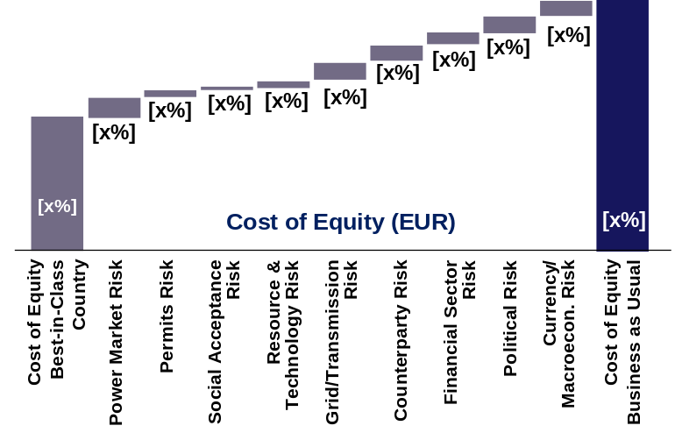
- The DREI methodology identifies three core categories to classify public instruments. Each the three categories of public instruments addresses the risk-return profiles of renewable energy in a different way.
- Instruments that reduce risk, by addressing the underlying barriers that create investment risk. These instruments utilise policy and programmatic interventions. An example, might be the implementation of a transparent and well-formulated grid code. The DREI methodology terms these instruments “policy derisking instruments”.
- Instruments that transfer risk, by shifting risk from the private to the public sector. Examples might be a public loan, a loan guarantee, or a public insurance. The DREI methodology terms these “financial derisking instruments”.
- Instruments that compensate for risk, offering investors a higher financial return. Examples might be a feed in tariff premium, or a rebate for technology costs. The DREI methodology calls these “direct financial incentives”.

- The “financing cost waterfalls” above can assist policymakers to prioritize the selection of these public instruments (policy de-risking measures and financial de-risking measures ) to target specific risk categories and to reduce or transfer risk. The DREI methodology then calculates the levelized cost of electricity (LCOE) for each renewable energy technology based on the particular costs (investment costs, operating costs, financing costs) in Kazakhstan. By comparing the impact and cost of different combinations of public instruments on reducing renewable energy costs, the DREI methodology can assist in identifying the most cost-effective combinations of public instruments. For more information on the DREI methodology, please visit www.undp.org/DREI

Component 1: Large-Scale Renewable Energy: Policy and Financial De-risking
- First component of the proposed project will support the implementation of government policies and programmes to address the remaining non-financial barriers and risks to investment in large-scale renewable energy. This component will also provide technical assistance on the current cost of large-scale renewable energy technologies in Kazakhstan to support the design of financial instruments necessary to promote investment and reach 30% 2030 target. This will take the form of economic analyses which will require modelling of all financial components (tariffs, cost of equity, cost of debt, technology cost). This component will involve close collaboration and coordination with existing public financial actors, such as the KAZREFF and the IDB. The focus will be on ensuring the overall most efficient and cost-effective approaches to catalyzing large-scale renewable energy investment. Specifically, the project will provide support in the following areas:

    - Power market development: Economic analyses into cost-effective and coordinated design of policy and financial derisking instruments to achieve 2030 target; improving mechanisms and procedures for feed-in tariffs and power purchase agreement; recommendations on guarantee scheme for PPAs;
    - Grid and transmission network: develop a grid code for renewable energy technologies; provide support for grid management and grid planning; assessments of balancing costs for renewable energy;
    - Feed in tariff: regular studies on tariff-setting for different large-scale renewable energy technologies, in order to ensure the feed in tariff is up to date and functioning optimally;
    - Currency support: recommendations on the requirement for financial products to address foreign currency risk for project developers.
    - Resource and technologies: national resource mapping and market study for solar PV, bioenergy and other relevant technologies.

Component 2: Renewable Energy for Life: Policy De-risking
- This component will support the design and implementation of government policies and measures to address specific barriers and risks to investment in small-scale renewable energy for homeowners and businesses. This will address both on-grid and off-grid solutions. Specifically, the following areas will be supported:
- Market development for small-scale RE: adoption of national and regional targets for small-scale RE, monitoring system and data-base for small-scale RES; regulations for small RES (i.e. net-metering policy); policies, targest and regulations to promote RES-based heat generation and integration of RES solution in building design;
- Improving processes for small RE approval, permits and grid connection: streamlined and simplified approval procedures for permits, grid-connection procedures and contracts with grid operator
- Enhancing social acceptance: campaigns to inform end-users/potential developers of the benefits of small-scale RE;
- Strengthening technology supply: standards, testing and certification to ensure long-term quality for solar PV, incuding support for domestic manufacturers with certification and quality improvement
- Capacity building and technical skills development: training, apprenticeships and university programmes to build skills for renewable energy (installation, operations and maintenance)

Component 3: Renewable Energy for Life: Financial De-risking and Incentives
- This component will provide both technical assistance and direct financial support (through financial derisking instruments and direct financial incentives) to develop and test business models for implementation and financing for small-scale renewable energy, focusing on two separate sub-components: RES for Urban Life (e.g. building-level RES applications) and RES for Rural Life (use of RES in rural areas and in agriculture) – see Table 5. Financial and business models will be identified based on economic analyses of the financial viability of small-scale renewable energy for different categories and profiles of buildings, houses and businesses and in partnership with private sector “champions” interested in experimenting with such business models and technologies (private sector parters will be identified via open call for expression of interest at PPG stage). This work will incorporate and build on existing government policies and baseline funding schemes (Renewable Energy Transfers Programme, Programme on Water Supply to Farming Communities KAZREFF, IsDB Renewable Energy Fund for Central Asia and others).

Table 5: Tentative scale of GEF-supported business models for urban and rural small-scale RES applications*
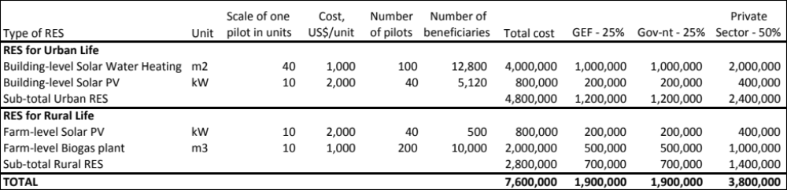
* costs estimates are based on current market price/supplier specifications in Kazakhstan for 10-20kW solar PV, 50 m2 solar water heating and 10m3 biogas system.

- RES for Urban Life: To promote application of RES systems in residential multi-appartment buildings, appropriate business and financial models will be developed featuring solar water heating/heat-pumps as green heating solutions and/or solar PV for on-grid power generation. Support will be provided to;

- Prepare financially viable model, including determining the level and type of needed public subsidy (see Table 6 for comparison of various green heating options), financing structure and the most appropriate and cost-effective combination of private and public resources, (re)-payment arrangements (leasing, PPAs, etc);
- Design business model and implementation scheme involving tenants/association of appartment owners (AAOs), ESCO companies (potential RESCOs), including appropriate legal/contractual arrangements (self-ownership, third-party ownership, community-based models);
- Provide training and build capacities of various project stakeholders (AAOs, tenants, R/ESCOs, building management companies) to implement proposed RES-solutions and put in place O&M provisions.

- RES for Rural Life: the focus will be on solar PV (and hybrid solar PV/wind), as well as on use of biogas by farming cooperatives/businesses. Support to design and implement the financial and business model will be provided to interested private sector partners, in particular:
- Identification of suitable technological solutions based on specific circumstances and needs of beneficiaries;
- Preparation of financial and economic studies, including the level and form of required public subsidies and support with securing debt and public financing
- Technology implementation, including securing appropriate warranties and provison of training on O&M
- Legal and institutional support.

- In conjuction with implementation of business models for RES applications in urban and rural context, collaboration with domestic banking sector will be established to facilitate and support the design of financing products for these business models and promote mass market for RES products and services (i.e. leasing scheme for solar PV; loans for RESCOs, etc). Using project-supported examples as “business case studies”, the project will raise awareness and educate banking sector about pecurlarities of RES projects, their risk/return profile, help design RES-specific due diligence tools and provide training to bank staff on their application. Recommendations will also be provided to the Government on the design of possible public loans and guarantees schemes to complement commercial lending.

- By simultaneously supporting the government in adopting policy measures which address non-financial barriers and risks to renewable energy investment, and providing technical assistance in the design of financial instruments which are necessary to promote investment, the project expects to support the Government of Kazakhstan in reaching the 2030 and 2050 targets for renewable energy in the most cost-efficient way.
Table 6: Comparison of green heat production alternatives for multi-family apartment buildings
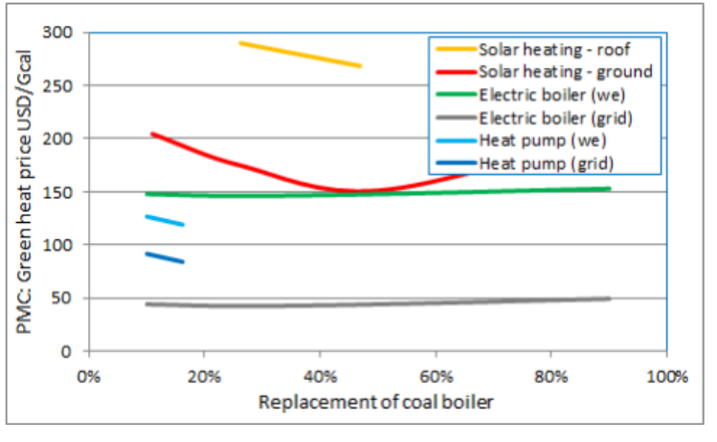
Source: Feasibility study for rehabilitation of life-support systems in small settlements, UNDP Kazakhstan 2014

- GEF focal area strategies: The Project is fully consistent with the GEF-6 Strategic Objective 1/Program 1 “Promote the timely development, demonstration, and financing of low- carbon technologies and mitigation options” which specifically envisages “supporting measures to de-risk low-emission investments”, as well as the design of shared and transparent methodologies and their applications to help assess and reduce the risks of such investments. Proposed UNDP-GEF project will apply UNDP’s DREI framework to do exactly this.

1.4 Global environmental benefits (GEFTF)
- Global environmental benefits in the form of GHG emissions reductions have been tentatively and conservatively estimated at 129,409 tCO2e in direct GHG emissions and up to 5.2 mln tCO2/year indirectly (top-down) (see Tables 7 and 8).

Table 7: Estimated direct GHG emissions reduction

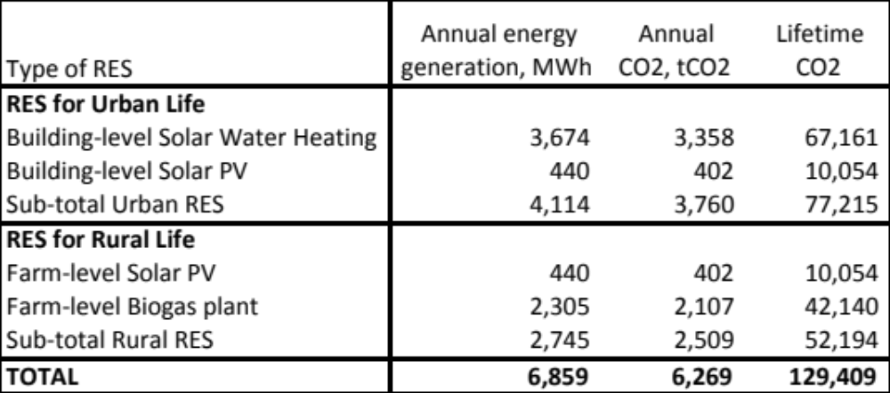
Table 8: Estimated indirect GHG emissions reduction
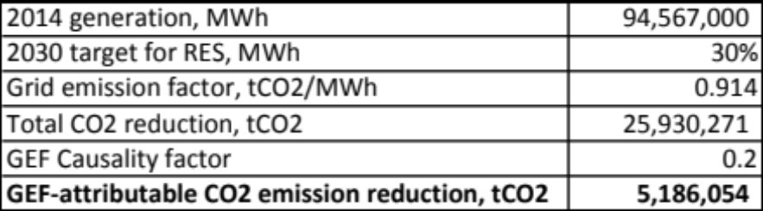
1.5 Innovativeness, sustainability and potential for scaling up
- Innovativeness: The innovativeness of the project stems from migrating from a conventional, project-based approach to a sector-wide transformational approach based on rigorous methodology to qualitatively and quantitatively assess risks from private sector perspective and propose most cost-effective combination of policy and financial derisking tools and incentives to address these risks. The methodological and evidence-based approach promoted by the UNDP-implemented, GEF-financed project, complemented by the establishment of necessary institutional and enabling conditions, will be instrumental in leveraging private funding to support the achievement of Kazakhstan’s 2030 RES target.

- Sustainability: the project originates from and is driven by the Government of Kazakhstan’s ambition to establish and achieve long-term RES and climate change mitigation targets. Secondly, it puts emphasis on private sector as the driving force for achieving the targets and transforming the market for renewable energy. By adopting a strategy, which focuses first and foremost on reducing investment risks, the project is destined to make a long-lasting impact. Sustainability of project’s outcomes will be based on the following provisions embedded in project design:
- RES-supportive policies will form an integral part of the broader Green Economy legislative package which spells out a set of measures to ensure Kazakhstan’s transition to more resource-effcient and green economic development pathway; the Green Economyc agenda and process is under direct auspices and leadership of the President of Kazakhstan;
- The project will support selected national agencies in full compliance with their existing mandate and power of authority thus making sure that lasting institutional and human capacities are created for implementation of project-supported policy changes.

- Sustainability and lasting impact of financial de-risking instruments will hinge upon their ability to lower the cost of financing for RE projects. Financial de-risking instruments will be designed in such a way as to achieve a sector-wide impact and lower down RE financing costs for ALL perspective RE projects and therefore eliminate or at least significantly reducing the need for additional financial de-risking after project completion.

- Potential for scaling-up: promoting renewable energy in Kazakhstan, the country with huge yet unexploited potential for RES (Figure 2), as well as solid economic base for investment and economic growth, has vast potential. Apart from obvious opportunities for large utility-scale RES projects, there are many smaller niche markets for RES applications in Kazakhstan, which are yet unknown to potential investors, developers and general public. Proposed project will look specifically at unleashing such new market opportunities under “RES for Urban Life” and “RES for Rural Life” segments; each with vast potential for scaling-up (bearing in mind projected 4.4% annual growth in electrcity demand, coming mainly from residential sector).

2. Stakeholders. Will project design include the participation of relevant stakeholders from civil society and indigenous people? (yes /no ) If yes, identify key stakeholders and briefly describe how they will be engaged in project design/preparation.

- Following organizations will represent civil society and will be closely involved in project design:
- KazEnergy – Association of Kazakhstan energy producers (including RES) will be consulted during risk analysis and identification of appropriate policy and financial derisking instruments under Component 1
- Kazakhstan Green Building Council will be involved in design of policy and financial derisking instruments to promote “RES for Urban Life” market segment under Components 2 and 3
- Association of AAO (Building-level Associations of Appartment Owners and Tenants) will be involved in design of business and financial models for pilot projects under “RES for Urban Life” sub-component
- Association of Farmers and Farming Cooperatives will be involved in design of business and financial models for pilot projects under “RES for Rural Life” sub-component.

- The project will directly support indigenous communities of Kazakhs shepherds, living traditional nomadic or semi-nomadic lifestyle and therefore not being able to use and benefit from centralized grid-connected energy supply system. The project will directly benefit at least 240 such “off-grid” indigenous communities by facilitating their access to sustainable and RES-based energy sources.

3. Gender Considerations. Are gender considerations taken into account? (yes /no ). If yes, briefly describe how gender considerations will be mainstreamed into project preparation, taken into account the differences, needs, roles and priorities of men and women.

- Gender issues will be mainstreamed in the design of Components 2 and 3 of the project as follows:
- Component 2 “Renewable Energy for Life: Policy De-risking“: at least 50% of beneficiaries for traning and capacity building related to RES are women and/or women-headed organizations (i.e. Associations of Appartment Owners, SMEs, farming communities);
- Component 3 “Renewable Energy for Life: Financial De-risking and Financial Incentives” at least 50% of beneficiaries for project-supported “RES for life” applications in cities and rural areas will be women.

- The project will also address gender aspects in the following ways throughout the life cycle of the proposed project: 1) Project preparation activities will include a baseline analysis of women’s potential roles and capacities for promotion of “RES for life”; 2) The project will apply a gender marker as per UNDP guidance; 3) The project will incorporate gender issues in the project results framework, including gender-sensitive actions, indicators, targets, and/or budget; 4) The project will monitor the share of women and men as direct beneficiaries; and 5) An analysis of women’s inclusion in project activities will be included in both the mid-term evaluation and the terminal evaluation of the project and will be explicitly stated in the terms of reference for those evaluations.

4. Risks. Indicate risks, including climate change, potential social and environmental risks that might prevent the project objectives from being achieved, and, if possible, propose measures that address these risks to be further developed during the project design (table format acceptable).

Risk Description | Level of Risk | Mitigation Measures
Political  Creating enabling environmental for private investment in RES requires strong political leadership, commitment and buy-in. Frequent changes and restructuring in the Government of Kazakhstan create risk that such political commitments may be difficult to sustain. | Medium | Project design is rooted and based on the national commitments and targets stated and adopted at the highest possible level, i.e. by the President, the Parliament and the Government of Kazakhstan. Any proposed revisions in the policies, as well as new ones to be proposed by the project will also have to secure the highest level of approval, i.e. by the Parliament (revision in the Law) or by the Government (e.g. changes in the feed-in tariffs).
Economic risks  International oil prices are expected to continue fluctuating with a progressive long-term tendency to the high as global oil reserves keep rarefying. Many of the renewable energy solutions proposed in this project are therefore not expected to become economically competitive compared to baseline energy sources, oil & gas. | High | Unless appropriate policies and regulations, supported by financial de-risking mechanisms and incentives are introduced and enforced, RE will not be able to compete with fossil fuel based power generation in Kazakhstan. Component 2 of this project therefore aims precisely at achieving these goals and leveling playing field for RE.
Market  Private investors do not find RES investments sufficiently attractive | Low | The project adopts private investors’ perspective to the analysis of risk, underlying barriers and the design of derisking strategy. Already at PIF design stage several investors have been interviewed and at PPG stage detailed quantitative analysis of investment risk will be conducted based on DREI framework and methodology. Also, proposed set of policy and financial derisking tools will be discussed with investors.
Technology implementation risk  Domestic supply chain and capacities for RES in Kazakhstan are very limited – this may cause inadequate implementation of RES projects leading to sub-optimal performance, mal-functioning, etc. | High | First, the project will involve top-level international technical specialists with experience of implementing RES projects in developing countries to provide quality assurance throughout all stages of pilot RES project design and implementation. Second, a significant share of Component 2 will be devoted to building domestic capacity for RES, through provision of vocational training and other type of learning and educational activities. Finally, domestic quality certification scheme for certain type of RES (e.g. solar PV) will be proposed and implemented to ensure minimum quality standards for RES projects.
Financial risk  Co-financing for pilot projects doesn’t materialize due to lack of private sector interest and/or government commitment | Low | Government co-financing for pilot RES for life project will be provided from the state-funded Programs with approved budgets; to be confirmed through the signed letters of co-financing at PPG stage. Similarly, several expressions of interest from private sector have been received during PIF development and will be confirmed through letters at PPG stage.
Climate change risk  Climate change poses two categories of risks for the deployment of RES in Kazakhstan. First, intensified frequency and scale of natural disasters pose risks to any infrastructure, including to RES projects. Second, availability of some RE resources might be affected as a result of climate change (e.g. hydro) | Medium | Resource risk will be mitigated through diversification of targeted RES, solar, wind, biogas, etc. In fact, solar and wind resources, where the largest potential exist in Kazakhstan, are not expected to be negatively affected by the changing climate With regard to infrastructure risks caused by climate-induced events, for each pilot investment climate risk assessment will be conducted and mitigation strategy proposed as part of pilot project design

5. Coordination. Outline the coordination with other relevant GEF-financed and other initiatives.

- UNDP-GEF “Energy-Efficient Design and Construction of Residential Buildings”project is in its final year of implementation. The proposed project will build upon its results in the area of promotion and adoption of EE building codes and voluntary green building standards, with a particualr focus on integrating RES-based solutions in building design.

- UNDP-GEF “Nationally Appropriate Mitigation Actions for Low-carbon Urban Development” (NAMA) is on-going initiatived aimed at promoting urban climate commitments and appropriate mitigation measures in cities, including RES. NAMA project will work closely with “RES for Urban Life” sub-component of the proposed project to realize synergies and avoid duplication.

- The proposed project will closely coordinate with other initiatives in Kazakhstan on renewable energy, in particular those initiatives by the IFC/EBRD, IDB, and other IFIs. Indeed the specific purpose of the Deriskign methodology to be taken by the project is to assist in identifying a comprehensive package of the most cost effective interventions, both by UNDP and possible coordinating partners.

6. Consistency with National Priorities. Is the project consistent with the National strategies and plans or reports and assessements under relevant conventions? (yes /no ). If yes, which ones and how: NAPAs, NAPs, ASGM NAPs, MIAs, NBSAPs, NCs, TNAs, NCSAs, NIPs, PRSPs, NPFE, BURs, etc.

- The Project reflects Government priorities to promote sustainable development and the commitment to mitigate GHG emissions under the UNFCCC. In 1995 Kazakhstan ratified the UNFCCC as a non-Annex I party, and in 1999 committed to join industrialized nations in their effort to limit GHG emissions and accept a binding and quantified emission limitation of 100% over a 1992 baseline. Further, in 2010 Kazakhstan announced and communicated to the Parties its additional voluntary commitments to reduce GHG emissions by 15% by 2020 below 1990 emissions and by 25% by 2050.

- The project is fully consistent with findings presented in the Third-Sixth National Communication (NC) to UNFCCC submitted by the Republic of Kazakhstan in 2013. Specifically:
- Energy sector makes the largest contribution to the total national GHG emissions in Kazakhstan: in 1990-2011 its contribution, excluding carbon removals by forests, ranges from 82% to 86%
- NC identifies actions to promote and integrate renewable energy soirces in the electricity mix as the most effective climate change mitigation measures, the NA in particular says that “the most effective measure to reduce CO2 emissions in the electricity sector can give the development of power generation capacity on the basis of renewable energy sources (RES)” (p. 82) and that the reduction of greenhouse gas emissions and increasing the share of renewable energy in total energy consumption are the two strategic objectives defined by the Government (p. 78).

- Consistent with the recommendations and conclusions of the III-VI NC, promotion of RES is also recognized as national priority measure for climate change mitigation in the draft Intended Nationally Determined Contribution (INDC) to be submitted by the Government of Kazakhstan to UNFCCC in 2015.

7. Knowledge Management. Outline the knowledge management approach for the project, including, if any, plans for the project to learn from other relevant projects and initiatives, to assess and document in a user-friendly form, and share these experiences and expertise with relevant stakeholders.

- Proposed project is one among several UNDP-implemented GEF-financed projects which are being designed and implemented based on UNDP’s DREI framework and methodology. UNDP will facilitate regular exchange of knowledge and progress in DREI implementation among “sister” projects, as well as systematic collection, analysis and presentation of DREI case studies, assessment tools and lessons learnt through the corporate platform established at http://www.undp.org/drei. Other related approved projects include:
- UNDP-GEF “NAMA Support for the Tunisia Solar Plan”;
- UNDP-GEF “ Promoting Low Carbon Energy Solutions in Nigeria Energy/Power Supply”.

PART III: APPROVAL/ENDORSEMENT BY GEF OPERATIONAL FOCAL POINT(S) AND GEF AGENCY(IES)
- Record of Endorsement of GEF Operational Focal Point (S) on Behalf of the Government(s): (Please attach the Operational Focal Point endorsement letter(s) with this template. For SGP, use this SGP OFP endorsement letter).
Name | Position | Ministry | Date (MM/dd/yyyy)
TMr. Akhsambiyev | GEF Operational Focal Point  Vice-Minister of Energy | Ministry of Energy | 01/28/2015
- GEF Agency(ies) Certification
This request has been prepared in accordance with GEF policies and procedures and meets the GEF criteria for project identification and preparation under GEF-6.

Agency Coordinator, Agency name | Signature | Date  (MM/dd/yyyy) | Project Contact Person | Telephone | Email
Adriana Dinu  UNDP – GEF Executive Coordinator |  | July 31, 2015 | Marina Olshanskaya  UNDP-GEF Regional Technical Adviser | +90-545-908-66-04 | marina.olshanskaya@undp.org

Project ID number will be assigned by GEFSEC and to be entered by Agency in subsequent document submissions.
When completing Table A, refer to the GEF Website, Focal Area Results Framework which is an Excerpt from GEF-6 Programming Directions.
Financing type can be either investment or technical assistance.
For GEF Project Financing up to $2 million, PMC could be up to10% of the subtotal; above $2 million, PMC could be up to 5% of the subtotal. PMC should be charged proportionately to focal areas based on focal area project financing amount in Table D below.
From the total amount fo 29.5 mln US$ expected for capitalization of EBRD/CIF KAZREFF only 5.5 mln US$ is counted as co-financing – reflecting the intention to collaborate with KAZREFF on designing and financing a package of “RES-for Life” projects
PPG requested amount is determined by the size of the GEF Project Financing (PF) as follows: Up to $100k for PF up to $3 mil; $150k for PF up to $6 mil; $200k for PF up to $10 mil; and $300k for PF above $10m. On an exceptional basis, PPG amount may differ upon detailed discussion and justification with the GEFSEC.
PPG fee percentage follows the percentage of the Agency fee over the GEF Project Financing amount requested.
Provide those indicator values in this table to the extent applicable to your proposed project. Progress in programming against these targets for the projects per the Corporate Results Framework in the GEF-6 Programming Directions, will be aggregated and reported during mid-term and at the conclusion of the replenishment period.
Kazakhstan National Inventory Report to UNFCCC, 2014
U.S. Energy Information Administration, International Energy Statistics Database
UNDP (2014), Sustainable Energy and Human Development in Europe and the CIS
UNDP and GEF (2012), Transforming on-Grid Renewable Energy Markets – A Review of UNDP-GEF Support for Feed-in Tariffs and Related Price and Market-Access Instruments.
Waissbein, O., Glemarec, Y., Bayraktar, H. and Schmidt, T. S. (2013), De-Risking Renewable Energy Investment: A Framework to Support Policymakers in Selecting Public Instruments to Promote Renewable Energy Investment in Developing Countries, UNDP: New York.
There are only few cases when risks for large scale RES projects are of less relevance for the small-scale category. For example, “counterparty risk” (the Settlement Center) is less of a risk for small-scale – while there is some net-metering, on-grid small-scale is less dependent on the off-taker than a large-scale developer, and off-grid small-scale is not dependent at all. Similarly, the “currency risk” for small-scale is much less significant than for large-scale projects: the currency risk only happens if you have hard-currency lending and local currency revenues (what often happens in large-scale). For small-scale, most lending to homehouseholds will most likely be in local currency through local banks.
Grid emission factor for Kazakhstan, 0.914 tCO2e/MWh (combied margin -2015), is based on EBRD’s report available at: http://www.kazenergy.com/images/stories/Pravovaia_baza/metodiki/27_06_2013/pril_1.pdf
https://unfccc.int/files/national_reports/annex_i_natcom_/application/pdf/kaz_nc3,4,5,6_eng.pdf
For regional and/or global projects in which participating countries are identified, OFP endorsement letters from these countries are required even though there may not be a STAR allocation associated with the project.
GEF policies encompass all managed trust funds, namely: GEFTF, LDCF, and SCCF

